# **-- Monthly Coordination Call Agenda --**

# **Technical Steering Committee / Work Group Co-Chairs /**

# **RHPWG Subcommittee Leads**

December 19th, 2018 11:30 am – 1:00 pm Pacific

Call in Number: (800) 768-2983

Access Code: 661 987 6342

Web Login: <https://cc.callinfo.com/r/1va38zvbs4clh&eom>

Call materials available on TSC webpage and WRAP calendar.

* Welcome, Roll Call, and Agenda Review (10 minutes) – Frank
  + Review and approve notes from October 31st call
  + Notes for this call – Kris Ray
* WRAP Workplan Revision (10 minutes) – Frank
  + Summary of Workplan Revisions
  + Workplan Revisions Schedule and Process
* Work Group Status Reports (informational only progress updates since SLC meeting, hold discussion) – (30 minutes) – **Work Group Co-Chairs – 5 minutes each TDWG, FSWG, OGWG, & RTOWG – 10 minutes RHPWG** - (see [Status Report Guidance](http://wrapair2.org/calendar/attachments/22426/18160/Work%20Group%20%20Subcommittee%20Status%20Report%20Guidance.docx))
* TSC Administrative and Informational Items – Frank, and Tom
  + **Discuss Coordination Needs Identified Above** (5 minutes) – Frank
  + **Action Items** (20 minutes)
    - Additions to Work Products/Deliverables Docket – Tom
      * [Workplan Implementation Guidance - Completion, Dissemination and Sharing of Work Products and Deliverables](http://www.wrapair2.org/pdf/WorkGroupGuidanceInfoDissem%20Sharing_approved%20by%20consensus31Oct2018.pdf) (October 31, 2018)
      * [Work Product / Deliverable Docket](http://www.wrapair2.org/TSC_Docket.aspx) (periodic updates)
    - Update TSC, Work Group and Subcommittee Membership and Contact Information - Tom
    - Ad hoc WRAP Website group - Tom
  + **Informational Items** (5 minutes)
    - IMPROVE data substitution – Pat
* Next Steps and Wrap up (10 minutes)
  + Review next steps and action items from call – Frank
  + Next call – January 30th call, Wednesday 11:30 am – 1:00 pm Pacific – Tom
    - Note taker, Bob Kotchenruther
    - Agenda items?

**Call and Note Taking Schedule**



**WRAP Workplan Timeline to Support Regional Haze Progress Reporting**

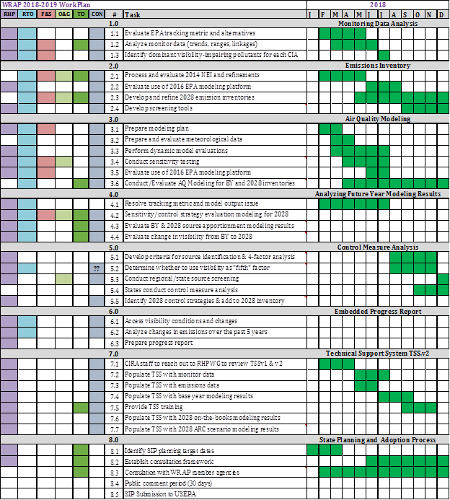

**WRAP Workplan Timeline to Support Regional Technical Analysis**

